**Birds migratory behavior increases lineages spread but do not rise local diversity and prevalence of haemosporidian parasites - Accepting title suggestions!**

Daniela de Angeli Dutra¹*, Antoine Filion¹, Alan Fecchio², Érika Martins Braga³, Robert Poulin¹

danideangeli@live.com

afilion90@gmail.com

alanfecchio@gmail.com

embraga@icb.ufmg.br

robert.poulin@otago.ac.nz

1. Department of Zoology, University of Otago, Dunedin, New Zealand

2.Departamento de Botânica e Ecologia, Universidade Federal do Mato Grosso, Brazil

3.Departamento de Parasitologia, Instituto de Ciências Biológicas, Universidade Federal de Minas Gerais, Brazil

1.Introduction

Migration has an important impact on the transmission of pathogens around the world because migrant species can transmit pathogens between two or more locations and be exposed to more infectious agents. In this way, migrant species might play an important role in the evolution and distribution of parasites and facilitate the spread of pathogens to new areas and new hosts species. Besides that, introduced pathogens and host species can decrease the fitness and survival of resident and native species, compromising the population abundance of local species and reducing community diversity (Callaway and Ridenour, 2004; Prenter et al., 2004). Conversely, the spread of pathogens might increase diversity by reducing competition pressures and, therefore, avoiding competitive exclusion. Recent studies have documented the influence of migratory birds on the spread of important pathogens with some of these able to infect humans (Alekseev et al., 2001; Hellgren et al., 2007; Lindeborg et al., 2012; Morshed et al., 2005; Poupon et al., 2006; Pulgarín-R et al., 2019; Ricklefs et al., 2017). Thus, the migratory behaviors of birds may influence directly local diversity and population size. In addition, pathogen spread might act as an environmental filter to new species colonization.

Recently, it was suggested that some parasites, specifically avian malaria and related haemosporidians, could be used as geographical markers in migratory birds (Marzal, 2012). Previous research has demonstrated differences in the timing of main occurrence of haemosporidian infection of migrating birds. These studies suggested that differences in haemosporidian lineages could indicate whether birds had become infected in different areas (Marzal, 2012). Because migratory birds connect distinct geographic regions they might influence local pathogen transmission. Since most haemosporidians cause life-long infections, parasites may travel across long distances with their bird host during migration. Therefore, allowing them to infect new vectors and new avian hosts in novel environments (Fecchio et al., 2020). Indeed, migratory species are known for their potential to connect distant habitats and transfer large amounts of biomass and nutrients between ecosystems (Altizer et al., 2011). Furthermore, O’Connor et al. 2020 have demonstrated that migratory birds do not present higher immune gene diversity in wetter areas, which could render them more susceptible to pathogens in those regions. For this reason, it might also be expected that migratory birds host a more diverse range of parasites and might be more susceptible to parasite infections.

South America is composed of different types of biomes, such as Amazonia, Brazilian Savanna, Atlantic Rain Forest and Pantanal, which holds a great diversity of native resident and migratory bird species. Previous research has documented the prevalence of avian malaria in different regions of Brazil, and markedly different prevalence for *Plasmodium* spp have been reported (Braga et al., 2011). In Brazil, the most prevalent avian haemosporidian parasite genus is *Plasmodium* (Braga et al., 2011), however, recently research conducted in Northeast Brazil reported higher prevalence of *Haemoproteus* parasites in this region (unpublished data). *Plasmodium* parasites present higher host-shifting rates (Hellgren et al., 2007), which could certainly contribute to the dissemination of haemoparasites by migratory birds. Indeed, host-shifting of a *Plasmodium* species from domestic chicken to wild and native birds has already been reported in Brazil .

Furthermore, the great avian diversity (~3000 species) and abundance in South America could also enhance the probability of parasite host-shifting between migratory and resident birds, given the likely presence of susceptible birds in any particular area. Besides that, the great diversity and abundance of vectors could also increase the chances of host-shifting between migratory and resident birds as it increases the chances of compatible vectors being present. Ferreira et al., 2016 have identified the potential vector of avian haemosporidian parasites in Brazil, revealing Mansonia and Culex as vectors of *Plasmodium* and Psorophora as a vector of *Haemoproteus*. Thus, these features make the Brazilian avian haemosporidians a great model to investigate the putative transmission of pathogens via host migration in nature.

In this context, the main goal of my thesis is to evaluate the influence of migratory birds on the spread of haemosporidian parasites in South America Specifically. I hypothesize that (1) migratory birds spread parasite lineages along their migratory routes, and (2) localities crossed by more migratory routes have greater prevalence and diversity of haemosporidian lineages. For the first hypothesis, we tested whether parasite lineages found (i) only in migratory birds, (ii) in both migrants and residents, and (ii) only in residents, differ in their frequency of occurrence among localities. Due to the fact migrants can carry parasites from many sites and infect resident birds, we predicted that parasite lineages using migratory birds will occur in a greater percentage of localities than those using only resident birds. Moreover, migration behavior increases the exposure of birds to more parasites lineages, thus we also expected higher proportion of lineages in migratory than resident birds.

2. Methods

2.1 Dataset

All the analyses were performed using MalAvi database (<http://130.235.244.92/Malavi/>) from South America regions and another dataset containing ~13200 bird blood samples from 63 different locations sampled from 2005 to 2018 in South America, mainly in Brazil (Figure 1). Combining both datasets, we obtained a total of ~2800 parasites lineages. The parasite prevalence (*Plasmodium* and *Haemoproteus*) was estimated using PCR diagnostic protocols described by Fallon et al. 2003 and Hellgren et al., 2004. The parasite lineages were identified by the PCR protocol described by Hellgren, Waldenstro, and Bensch 2004. This protocol produces a *cyt b* fragment of 478 bp. The birds present in each locality will be classified in five ecological classes: (1) resident; (2) partial migrant and (3) migrant, according to the Brazilian Committee of Ornithology Records - CRBO 2014, Somenzari et al. 2018 and BirdLife International (<https://www.birdlife.org/>).

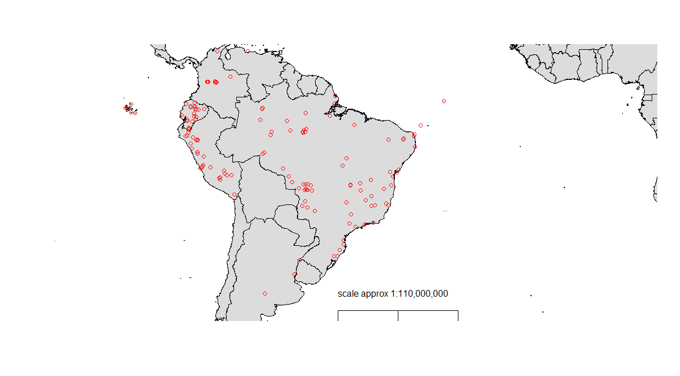 Figure 1: Bird collection points.

2.2 Correlations

*Spatial and temporal correlation*

We determined the spatial correlation for prevalence and parasite richness applying the Moran Index value. In order to estimate these analyses, we combined the coordinates data in a matrix and employed the function “Moran.I” from “Ape” package in R. Temporal correlations analyses were performed using linear models. For prevalence we conducted a mixed linear model using package “lme4” in R function “lmer”. Firstly, we grouped the data by year and location employing “group_by” function from “dplyr” package in R. Then, we compared the prevalence per year of collection considering number of birds collected and location as variables. For parasite richness, we performed a simple linear model using “lm” function.

*Phylogenetic Signal*

Aiming to estimate phylogenetic signal for our dataset, we downloaded the file AllBirdsHackett1.tre from <https://birdtree.org/> website. Using “treeman” package in R, we created a treeman file containing all trees from the original file. Then, we randomly selected 100 trees. This new file was converted from treeman to a phylo file, from which we extracted one single random tree. Using “dplyr” package, we grouped our data per species and eliminate all bird species from the phylo tree which were not present in our data. Using “match” function from “picante” package, we matched the species from both data. Thus, we calculated lambda (λ) to determine the phylogenetic signal in the present dataset. In order to estimate lambda (λ) value we applied “phylosig” function from “phytools” package.

2.3 Statistical Analyses

*Bayesian model*

Aiming to determinate whether migratory birds spread parasite lineages along their migratory routes and to evaluate the parasite connectivity among localities due to migratory behavior, we conducted Bayesian analyses using “brms” package in R evaluating the percentage of locations crossed by lineages present in resident, partial migrant and migrant birds. Firstly, using “ape” package, we computed the phylogenetic expected variances and covariances from our bird species in an object to be incorporated in our Bayesian model. Secondly, we applied “get_priors” function to fit the priors for our model. We used as fixed variables the number of birds per site and parasite richness. As our Moran Index for parasite richness between location was low (-0.0008), we did not considered locality as a variable in or our model neither employed model correction for locality coordinates. Thus, we ran the model applying “Beta” family, 4 chains with 2000 total iterations per chain and 50% of warmup interactions. The model results were plotted using “conditional_effects” function.

*Mixed models*

Two mixed models were performed to estimate whether localities with more migratory birds have greater prevalence and diversity of haemosporidian lineages. With this objective, we employed “lmer” function from “lme4” package in R. In the first model, we considered parasite richness as dependent variable and percentage of migratory birds as independent variable. Host richness and prevalence were considered fixed variables and number of samples per site was settled as a random variable.

In the second model we analyzed the prevalence for each bird species between localities using biome and locality as random variables. For this we considered prevalence as our dependent variable, species as a factor of prevalence and percentage of migratory birds as our independent variable. In this model, we filtered our data for species with 10 or more apparitions. Apart from that, we employed the “trendline” function from the “basictrendline” package in R to create an trend plot. In this step, we again used prevalence as our dependent variable, species as a factor of prevalence and percentage of migratory birds as our independent variable.

3. Results

Our analyses demonstrate bird migratory behavior increases lineages spread but do not rise local diversity and prevalence of haemosporidian parasites. Our Bayesian model analyses revealed the lineages shared by resident and migratory species are more spread in our data (Figure 2). We also demonstrate that the lineages shared by all three categories are the most spread, followed by the one shared between resident and migratory and then resident and partial migratory species. Nevertheless, despite the fact lineages shared by migratory species and resident are more spread, linages present in only resident, migratory or partial migratory species present similar dispersal in our model.

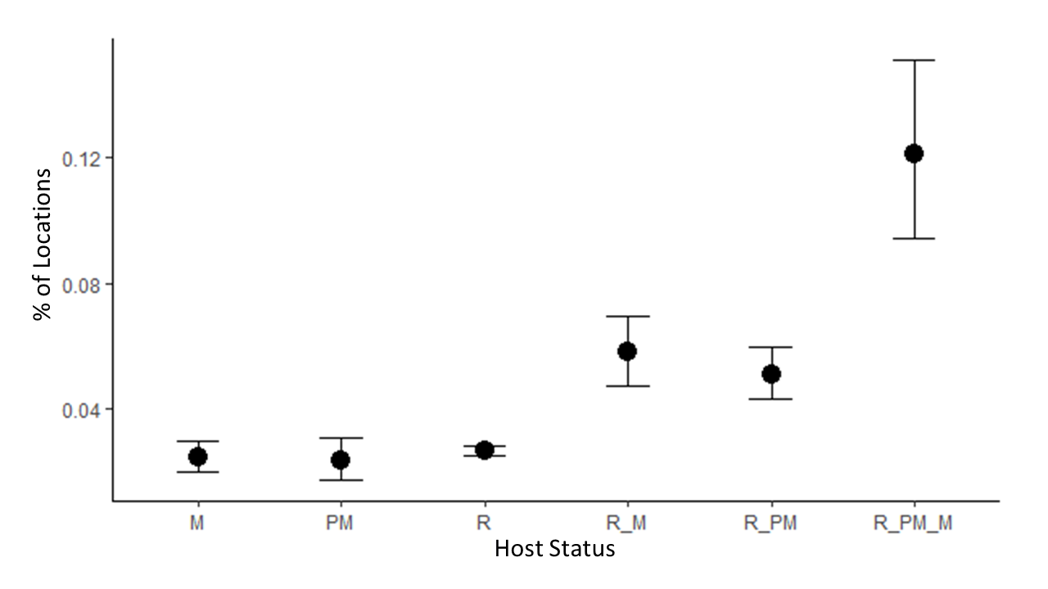

Figure 2: Bayesian model plot. Model demonstrates lineages shared by migratory species and resident are more spread. M = migratory, PM = partial migratory and R = resident.

Our first mixed model revealed there is no correlation between the percentage/presence of migratory bird species and parasite richness (p =0.48, Figure 3). We also did not observe correlation of migratory behavior and prevalence of haemosporidian parasites per species (p=0.11, Figure 4 ). Trendline analyses illustrates a straight line as the percentage of migrant species increases, demonstrating the absence of relation between migration behavior and prevalence per species (Figure 5).

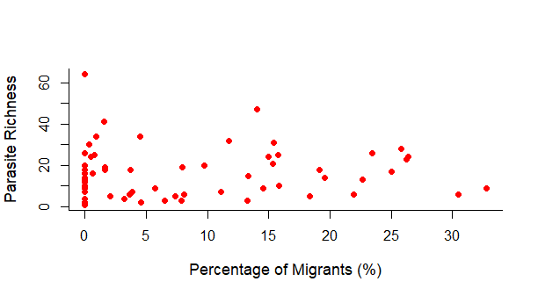

Figure 3: Correlation between percentage of migrants and parasite richness.

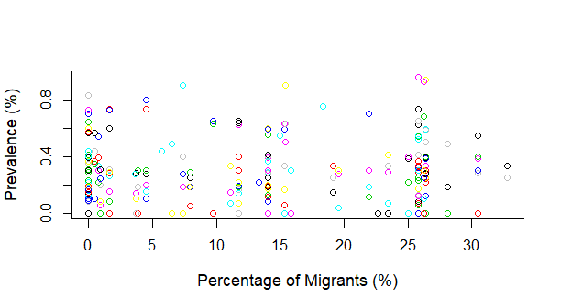

Figure 4: Correlation between percentage of migrants and prevalence per specie. Colors represent different host species.

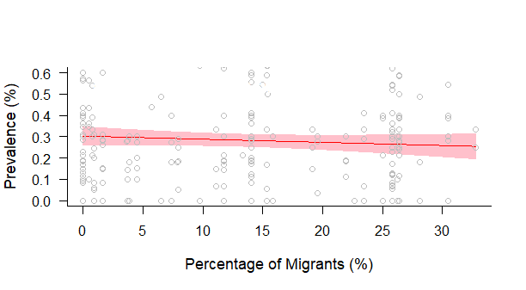

Figure 5: Correlation between percentage of migrants and prevalence per specie. Trendline demonstrates the absence of relation between migration behavior and prevalence per species.

The spatial and temporal correlation revealed there is no substantial effect of time or space in parasite richness, however, for prevalence, we observed a Moran Index effect of 0.15, and for this reason, locality was used as a random effect in our second mixed model. Likewise, considerable phylogenetic signals were observed for prevalence (0.49) and parasite richness (0.17). Considering this, phylogenetic covariation was added in Bayesian analyses and species were used as factors in the second mixed model.

References

Alekseev, A.N., Dubinina, H. V, Semenov, A. V, Bolshakov, C. V, 2001. Evidence of Ehrlichiosis Agents Found in Ticks ( Acari : Ixodidae ) Collected from Migratory Birds Evidence of Ehrlichiosis Agents Found in Ticks ( Acari : Ixodidae ) Collected from Migratory Birds. J. Med. Entomol. 38, 471–474. https://doi.org/10.1603/0022-2585-38.4.471

Altizer, S., Bartel, R., Han, B.A., 2011. Animal migration and infectious disease risk. Science (80-. ). 331, 296–302. https://doi.org/10.1126/science.1194694

Braga, É.M., Silveira, P., Belo, N.O., Valkiunas, G., 2011. Recent advances in the study of avian malaria: An overview with an emphasis on the distribution of Plasmodium spp in Brazil. Mem. Inst. Oswaldo Cruz 106, 3–11. https://doi.org/10.1590/S0074-02762011000900002

Callaway, R.M., Ridenour, W.M., 2004. Novel weapons: Invasive success and the evolution of increased competitive ability. Front. Ecol. Environ. 2, 436–443. https://doi.org/10.1890/1540-9295(2004)002[0436:NWISAT]2.0.CO;2

Comitê Brasileiro de Registros Ornitológicos - CRBO, 2014. Listas das aves do brasil. Com. Bras. Regist. Ornitológicos 1–38.

Fallon, A.S.M., Ricklefs, R.E., Swanson, B.L., Bermingham, E., 2003. Detecting Avian Malaria : an Improved Polymerase Chain Reaction Diagnostic Detecting Avian Malaria : an Improved Polymerase Chain 89, 1044–1047. https://doi.org/10.1645/GE-3157

Fecchio, A., Chagas, C.R.F., Bell, J.A., Kirchgatter, K., 2020. Evolutionary ecology, taxonomy, and systematics of avian malaria and related parasites. Acta Trop. 105364. https://doi.org/10.1016/j.actatropica.2020.105364

Ferreira-Junior, F.C., de Angeli Dutra, D., Silveira, P., Pacheco, R.C., Witter, R., de Souza Ramos, D.G., Pacheco, M.A., Escalante, A.A., Braga, E.M., 2018. A new pathogen spillover from domestic to wild animals: Plasmodium juxtanucleare infects free-living passerines in Brazil. Parasitology 1–10. https://doi.org/10.1017/S003118201800077X

Ferreira, F.C., Rodrigues, R.A., Sato, Y., Borges, M.A.Z., Braga, É.M., 2016. Searching for putative avian malaria vectors in a Seasonally Dry Tropical Forest in Brazil. Parasites and Vectors 9. https://doi.org/10.1186/s13071-016-1865-y

Hellgren, O., Waldenstro, J., Bensch, S., 2004. A New Pcr Assay For Simultaneous Studies Of Leucocytozoon, Plasmodium, And Haemoproteusfrom Avian Blood 90, 797–802. https://doi.org/10.1645/GE-184R1

Hellgren, O., Waldenström, J., Peréz-Tris, J., Szöll Ösi, E., Hasselquist, D., Krizanauskiene, A., Ottosson, U., Bensch, S., 2007. Detecting shifts of transmission areas in avian blood parasites - A phylogenetic approach. Mol. Ecol. 16, 1281–1290. https://doi.org/10.1111/j.1365-294X.2007.03227.x

Lindeborg, M., Barboutis, C., Ehrenborg, C., Fransson, T., Jaenson, T.G.T., Lindgren, P.-E., Lundkvist, Å., Nyström, F., Salaneck, E., Waldenström, J., Olsen, B., 2012. Migratory Birds, Ticks, and Crimean-Congo Hemorrhagic Fever Virus. Emerg. Infect. Dis. 18, 2095–2097. https://doi.org/10.3201/eid1812.120718

Marzal, A., 2012. Recent Advances in Studies on Avian Malaria Parasites. Malar. Parasites 135–158. https://doi.org/10.5772/33730

Morshed, M.G., Scott, J.D., Fernando, K., Beati, L., Mazerolle, D.F., Geddes, G., Durden, L.A., 2005. Migratory songbirds disperse ticks across Canada, and first isolation of the Lyme disease spirochete, Borrelia burgdorferi, from the avian tick, Ixodes auritulus. J. Parasitol. 91, 780–790. https://doi.org/10.1645/GE-3437.1

O’Connor, E.A., Hasselquist, D., Nilsson, J.Å., Westerdahl, H., Cornwallis, C.K., 2020. Wetter climates select for higher immune gene diversity in resident, but not migratory, songbirds. Proceedings. Biol. Sci. 287, 20192675. https://doi.org/10.1098/rspb.2019.2675

Poupon, M., Lommano, E., Douet, V., Rais, O., Schaad, M., Jenni, L., Gern, L., 2006. Prevalence of Borrelia burgdorferi Sensu Lato in Ticks Collected from Migratory Birds in Switzerland Prevalence of Borrelia burgdorferi Sensu Lato in Ticks Collected from Migratory Birds in Switzerland. Appl. Environ. Microbiol. 72, 976–979. https://doi.org/10.1128/AEM.72.1.976

Prenter, J., MacNeil, C., Dick, J.T.A., Dunn, A.M., 2004. Roles of parasites in animal invasions. Trends Ecol. Evol. 19, 385–390. https://doi.org/10.1016/j.tree.2004.05.002

Pulgarín-R, P.C., Gómez, C., Bayly, N.J., Bensch, S., FitzGerald, A.M., Starkloff, N., Kirchman, J.J., González-Prieto, A.M., Hobson, K.A., Ungvari-Martin, J., Skeen, H., Castaño, M.I., Cadena, C.D., 2019. Migratory birds as vehicles for parasite dispersal? Infection by avian haemosporidians over the year and throughout the range of a long-distance migrant. J. Biogeogr. 46, 83–96. https://doi.org/10.1111/jbi.13453

Ricklefs, R.E., Medeiros, M., Ellis, V.A., Svensson-Coelho, M., Blake, J.G., Loiselle, B.A., Soares, L., Fecchio, A., Outlaw, D., Marra, P.P., Latta, S.C., Valkiūnas, G., Hellgren, O., Bensch, S., 2017. Avian migration and the distribution of malaria parasites in New World passerine birds. J. Biogeogr. 44, 1113–1123. https://doi.org/10.1111/jbi.12928

Somenzari, M., Amaral, P.P. do, Cueto, V.R., Guaraldo, A.D.C., Jahn, A.E., Lima, D.M., Lima, P.C., Lugarini, C., Machado, C.G., Martinez, J., Nascimento, J.L.X. do, Pacheco, J.F., Paludo, D., Prestes, N.P., Serafini, P.P., Silveira, L.F., Sousa, A.E.B.A. de, Sousa, N.A. de, Souza, M.A. de, Telino-Júnior, W.R., Whitney, B.M., 2018. An overview of migratory birds in Brazil, Papéis Avulsos de Zoologia. https://doi.org/10.11606/1807-0205/2018.58.03